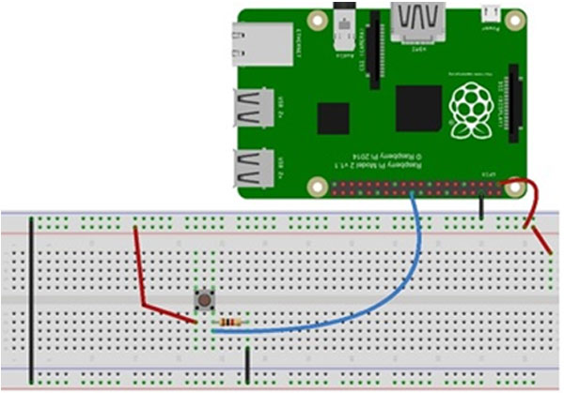

Use the above wiring layout with a 1k ohm resistor